FREQUENCIES VARIABLES=Admit P.Indicator R.Law C.Corruption P.Stability G.Effectiveness R.Quality

/STATISTICS=STDDEV VARIANCE RANGE MINIMUM MAXIMUM SEMEAN MEAN MEDIAN MODE SUM SKEWNESS SESKEW

KURTOSIS SEKURT

/ORDER=ANALYSIS.

**Frequencies**

[DataSet0]

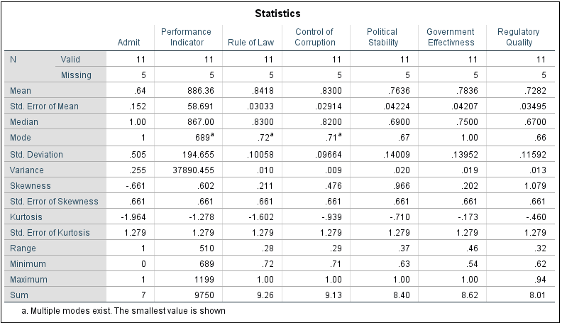

**Frequency Table**

|  |  |  |  |  |  |
| --- | --- | --- | --- | --- | --- |
| **Admit** | | | | | |
|  | | Frequency | Percent | Valid Percent | Cumulative Percent |
| Valid | 0 | 4 | 25.0 | 36.4 | 36.4 |
| 1 | 7 | 43.8 | 63.6 | 100.0 |
| Total | 11 | 68.8 | 100.0 |  |
| Missing | System | 5 | 31.3 |  |  |
| Total | | 16 | 100.0 |  |  |

|  |  |  |  |  |  |
| --- | --- | --- | --- | --- | --- |
| **Performance Indicator** | | | | | |
|  | | Frequency | Percent | Valid Percent | Cumulative Percent |
| Valid | 689 | 1 | 6.3 | 9.1 | 9.1 |
| 702 | 1 | 6.3 | 9.1 | 18.2 |
| 706 | 1 | 6.3 | 9.1 | 27.3 |
| 716 | 1 | 6.3 | 9.1 | 36.4 |
| 762 | 1 | 6.3 | 9.1 | 45.5 |
| 867 | 1 | 6.3 | 9.1 | 54.5 |
| 885 | 1 | 6.3 | 9.1 | 63.6 |
| 949 | 1 | 6.3 | 9.1 | 72.7 |
| 1118 | 1 | 6.3 | 9.1 | 81.8 |
| 1157 | 1 | 6.3 | 9.1 | 90.9 |
| 1199 | 1 | 6.3 | 9.1 | 100.0 |
| Total | 11 | 68.8 | 100.0 |  |
| Missing | System | 5 | 31.3 |  |  |
| Total | | 16 | 100.0 |  |  |

|  |  |  |  |  |  |
| --- | --- | --- | --- | --- | --- |
| **Rule of Law** | | | | | |
|  | | Frequency | Percent | Valid Percent | Cumulative Percent |
| Valid | .72 | 1 | 6.3 | 9.1 | 9.1 |
| .73 | 1 | 6.3 | 9.1 | 18.2 |
| .74 | 1 | 6.3 | 9.1 | 27.3 |
| .76 | 1 | 6.3 | 9.1 | 36.4 |
| .79 | 1 | 6.3 | 9.1 | 45.5 |
| .83 | 1 | 6.3 | 9.1 | 54.5 |
| .88 | 1 | 6.3 | 9.1 | 63.6 |
| .92 | 1 | 6.3 | 9.1 | 72.7 |
| .94 | 1 | 6.3 | 9.1 | 81.8 |
| .95 | 1 | 6.3 | 9.1 | 90.9 |
| 1.00 | 1 | 6.3 | 9.1 | 100.0 |
| Total | 11 | 68.8 | 100.0 |  |
| Missing | System | 5 | 31.3 |  |  |
| Total | | 16 | 100.0 |  |  |

|  |  |  |  |  |  |
| --- | --- | --- | --- | --- | --- |
| **Control of Corruption** | | | | | |
|  | | Frequency | Percent | Valid Percent | Cumulative Percent |
| Valid | .71 | 1 | 6.3 | 9.1 | 9.1 |
| .72 | 1 | 6.3 | 9.1 | 18.2 |
| .75 | 1 | 6.3 | 9.1 | 27.3 |
| .76 | 1 | 6.3 | 9.1 | 36.4 |
| .79 | 1 | 6.3 | 9.1 | 45.5 |
| .82 | 1 | 6.3 | 9.1 | 54.5 |
| .83 | 1 | 6.3 | 9.1 | 63.6 |
| .88 | 1 | 6.3 | 9.1 | 72.7 |
| .92 | 1 | 6.3 | 9.1 | 81.8 |
| .95 | 1 | 6.3 | 9.1 | 90.9 |
| 1.00 | 1 | 6.3 | 9.1 | 100.0 |
| Total | 11 | 68.8 | 100.0 |  |
| Missing | System | 5 | 31.3 |  |  |
| Total | | 16 | 100.0 |  |  |

|  |  |  |  |  |  |
| --- | --- | --- | --- | --- | --- |
| **Government Effectivness** | | | | | |
|  | | Frequency | Percent | Valid Percent | Cumulative Percent |
| Valid | .54 | 1 | 6.3 | 9.1 | 9.1 |
| .67 | 1 | 6.3 | 9.1 | 18.2 |
| .70 | 1 | 6.3 | 9.1 | 27.3 |
| .72 | 1 | 6.3 | 9.1 | 36.4 |
| .73 | 1 | 6.3 | 9.1 | 45.5 |
| .75 | 1 | 6.3 | 9.1 | 54.5 |
| .78 | 1 | 6.3 | 9.1 | 63.6 |
| .85 | 1 | 6.3 | 9.1 | 72.7 |
| .88 | 1 | 6.3 | 9.1 | 81.8 |
| 1.00 | 2 | 12.5 | 18.2 | 100.0 |
| Total | 11 | 68.8 | 100.0 |  |
| Missing | System | 5 | 31.3 |  |  |
| Total | | 16 | 100.0 |  |  |

|  |  |  |  |  |  |
| --- | --- | --- | --- | --- | --- |
| **Regulatory Quality** | | | | | |
|  | | Frequency | Percent | Valid Percent | Cumulative Percent |
| Valid | .62 | 1 | 6.3 | 9.1 | 9.1 |
| .63 | 1 | 6.3 | 9.1 | 18.2 |
| .65 | 1 | 6.3 | 9.1 | 27.3 |
| .66 | 2 | 12.5 | 18.2 | 45.5 |
| .67 | 1 | 6.3 | 9.1 | 54.5 |
| .69 | 1 | 6.3 | 9.1 | 63.6 |
| .73 | 1 | 6.3 | 9.1 | 72.7 |
| .85 | 1 | 6.3 | 9.1 | 81.8 |
| .91 | 1 | 6.3 | 9.1 | 90.9 |
| .94 | 1 | 6.3 | 9.1 | 100.0 |
| Total | 11 | 68.8 | 100.0 |  |
| Missing | System | 5 | 31.3 |  |  |
| Total | | 16 | 100.0 |  |  |

LOGISTIC REGRESSION VARIABLES Admit

/METHOD=ENTER R.Law C.Corruption P.Stability G.Effectiveness R.Quality

/CRITERIA=PIN(.05) POUT(.10) ITERATE(20) CUT(.5).

**Logistic Regression**

|  |  |  |  |
| --- | --- | --- | --- |
| **Case Processing Summary** | | | |
| Unweighted Casesa | | N | Percent |
| Selected Cases | Included in Analysis | 11 | 100.0 |
| Missing Cases | 0 | .0 |
| Total | 11 | 100.0 |
| Unselected Cases | | 0 | .0 |
| Total | | 11 | 100.0 |
| a. If weight is in effect, see classification table for the total number of cases. | | | |

|  |  |
| --- | --- |
| **Dependent Variable Encoding** | |
| Original Value | Internal Value |
| 0 | 0 |
| 1 | 1 |

**Block 0: Beginning Block**

|  |  |  |  |  |  |
| --- | --- | --- | --- | --- | --- |
| **Classification Tablea,b** | | | | | |
|  | Observed | | Predicted | | |
|  | Admit | | Percentage Correct |
|  | 0 | 1 |
| Step 0 | Admit | 0 | 0 | 4 | .0 |
| 1 | 0 | 7 | 100.0 |
| Overall Percentage | |  |  | 63.6 |
| a. Constant is included in the model. | | | | | |
| b. The cut value is .500 | | | | | |

|  |  |  |  |  |  |  |  |
| --- | --- | --- | --- | --- | --- | --- | --- |
| **Variables in the Equation** | | | | | | | |
|  | | B | S.E. | Wald | df | Sig. | Exp(B) |
| Step 0 | Constant | .560 | .627 | .797 | 1 | .372 | 1.750 |

|  |  |  |  |  |  |
| --- | --- | --- | --- | --- | --- |
| **Variables not in the Equation** | | | | | |
|  | | | Score | df | Sig. |
| Step 0 | Variables | Rule of Law | 7.438 | 1 | .006 |
| Control of Corruption | 5.349 | 1 | .021 |
| Political Stability | 4.158 | 1 | .041 |
| Government Effectivness | 5.651 | 1 | .017 |
| Regulatory Quality | 3.350 | 1 | .067 |
| Year | 7.700 | 1 | .006 |
| Overall Statistics | | 10.047 | 6 | .123 |

**Block 1: Method = Enter**

|  |  |  |  |  |
| --- | --- | --- | --- | --- |
| **Omnibus Tests of Model Coefficients** | | | | |
|  | | Chi-square | df | Sig. |
| Step 1 | Step | 14.421 | 6 | .025 |
| Block | 14.421 | 6 | .025 |
| Model | 14.421 | 6 | .025 |

|  |  |  |  |
| --- | --- | --- | --- |
| **Model Summary** | | | |
| Step | -2 Log likelihood | Cox & Snell R Square | Nagelkerke R Square |
| 1 | .000a | .730 | 1.000 |
| a. Estimation terminated at iteration number 19 because a perfect fit is detected. This solution is not unique. | | | |